

## Deccan Education Society’s FERGUSSON COLLEGE (AUTONOMOUS), PUNE-4

# Department of Computer Science

A

Project Report On **FINANCERS**

By

1. Arpita Makhamale 226236
2. Hardik Kothari 226207
3. Pooja Pawar 226248

[2022-2023]

Deccan Education Society’s

FERGUSSON COLLEGE (AUTONOMOUS), PUNE-4

**Department of Computer Science**

#### A

Project Report On **FINANCERS**

In partial fulfillment of requirements of the completion of F.Y. M. Sc (C.S.) Semester-I

**Master of Science Computer Science**

**(CSC4106) Computer Science project -1**

Submitted By:

##### Arpita Makhamale 226236

##### Hardik Kothari 226207

##### Pooja Pawar 226248

Under the Guidance of:

**Mr. Irfan Khatik**

# CERTIFICATE

#### This is to certify that the project entitled **FINANCERS**

completed by 1.Arpita Makhamale 2.Hardik Kothari 3.Pooja Pawar

#### in partial fulfillment of the requirement of the completion of M.Sc(C.S.) Semester-I, has been carried out by team under my guidance satisfactorily during the academic year 2022- 2023.

**Place**: Pune

**Date**: / /2022

Mr.Irfan Khatik (Dr. Kavita A. Khobragade)

##### Project Guide Head, Computer Science Department

**Internal Examiner External Examiner**

**ACKNOWLEDGEMENT**

We have taken efforts in this project. However, it would not have been possible without the kind support and help of **Mr. Irfan Khatik (**Project guide). We would like to extend our sincere thanks to all who helped us throughout the project.

We are highly indebted of Irfan sir for her guidance and constant supervision as well as for providing necessary information regarding the project & also for their support in completing the project.

Our thanks and appreciations also go to our batchmates in developing the project and people who have willingly helped us out with their abilities.

|  |  |
| --- | --- |
| **Arpita Makhamale** | **226236** |
| **Hardik Kothari** | **226207** |
| **Pooja Pawar** | **226248** |

|  |  |  |  |
| --- | --- | --- | --- |
| **Sr. No.** |  | **Topic** | **Page Number** |
| **1.** |  | **Introduction** |  |
|  | **1.1** | **Existing System & Problem Definition** |  |
|  | **1.2** | **Need for the New system** |  |
|  | **1.3** | **Overview of the Project** |  |
| **2.** |  | **Analysis** |  |
|  | **2.1** | **Feasibility Study** |  |
|  | **2.2** | **Hardware Requirements** |  |
| **3** . |  | **Design** |  |
|  | **3.1** | **Database Table Designing** |  |
|  | **3.2** | **UML Diagram**  **Sequence Diagram, Activity Diagram, Deployment Diagram** |  |
|  | **3.3** | **Input and Output Screens And Reports** |  |
| **4.** |  | **Testing** |  |
|  | **4.1** | **Test cases and Test Results** |  |
| **5.** |  | **Limitations and Future Enhancements** |  |
| **6.** |  | **Conclusion** |  |
| **7.** |  | **References and Bibliography** |  |

# Index

1. **INTRODUCTION**

A stock market, equity market, or share market is the aggregation of buyers and sellers of [stocks](https://en.wikipedia.org/wiki/Stock) (also called shares), which represent [ownership](https://en.wikipedia.org/wiki/Ownership) claims on businesses; these may include *securities* listed on a public [stock exchange](https://en.wikipedia.org/wiki/Stock_exchange), as well as stock that is only traded privately, such as shares of private companies which are sold to [investors](https://en.wikipedia.org/wiki/Investor) through [equity crowdfunding](https://en.wikipedia.org/wiki/Equity_crowdfunding) platforms. Investment is usually made with an [investment strategy](https://en.wikipedia.org/wiki/Investment_strategy) in mind.

* 1. **Detailed Problem Definition**

Currently trading platform are depends on the algorithms.

Algorithmic trading is the process where a preprogrammed trading instruction is fed to the computer program in order to execute an automated trade, specific instructions can be assigned for variable.

##### Is algorithmic trading profitable?

There are many traders, both institutional and independent that are using algorithms profit from these in efficiencies and in many ways, algorithmic trading can often be more profitable than traditional discretionary trading since much of the emotions is taken out of the trade selection and decision-making process. But if a new Trader comes in picture algorithmic trading becomes more difficult.

### 1.2 Need for New System

The current system is not very friendly to the new investors in the market. There are no parameter advisory features for them. They are totally dependent on the algorithm which is not user friendly.

Even though they understood algorithms but sometimes algorithms suggest the company which is their partner and some companies are unknown to the trades. News feed features in the existing system give irrelevant news even if you don't have interest in that field. They contain ads which feel irritating.

**1.3 Overview of the Project**

Financer is one destination for mutual funds and stocks. It will allow users to filter their choice and get the best solution available. It will also provide the user with real-time stock ranges.

It is a web-based application which will give information regarding stocks and mutual funds. After creating an account on website, user can access the features such as real-time Visual base stat analysis with help of that user can plan strategy. Quantity model helps the user to implement their strategy regarding their trading such as whether to buy, sell or hold the stock. The news feed feature will give information regarding stock market and companies in which user can trade.

##### Features of Financer are:

* + - Realtime Stock Analytics
    - Wide range of companies
    - Users can filter stocks and funds according to requirements
    - Wallet to compare profit and loss

**2.Analysis**

* 1. **Feasibility Study**

### Technical feasibility

The financers will be a complete web-based platform.

Each of the technologies which is used is freely available.

Initially the website will be hosted on the local host but later for implementations it will be hosted in a paid web hosting space with sufficient bandwidth from these aspects as of now the project Financer is technically feasible.

### Economic Feasibility

Being a totally web-based application, Financer will have an associated hosting cost after all the implementations are done. Since the system requires payment methods the bandwidth require for this operation will be sizable. The software and hardware specification of the system are being fulfilled by the existing personal computer there therefore there is no additional cost required to buy an additional computing system. No cost will be charged from the potential customer. In the initial stages the primary potential customers will be new traders and content will be offered to them without any charges. From these aspects Financers is economically feasible.

### Operational Feasibility

The financers will be providing patterns for trading in the stock market. This is a web-based platform, after creating an account, user can buy and sell stock and their profit will be stored in wallet.

* 1. **Hardware Requirement**

**Hardware Specification**

Minimum system requirements are:

* + - Ram: 4 GB
    - Processor: Intel i3
    - Hard drive: 500 GB

**Platform**

**Platforms used to build Financers are:**

* + - Operating System: Windows
    - Language: HTML, CSS, JavaScript, Python
    - Database: SQLite 3
    - API : **iexcloud** for Stock
      * **Unsplash** for images
      * **Google Charts** for charts

### 

**3.DESIGN**

* 1. **Database Table Designing (ER diagram)**

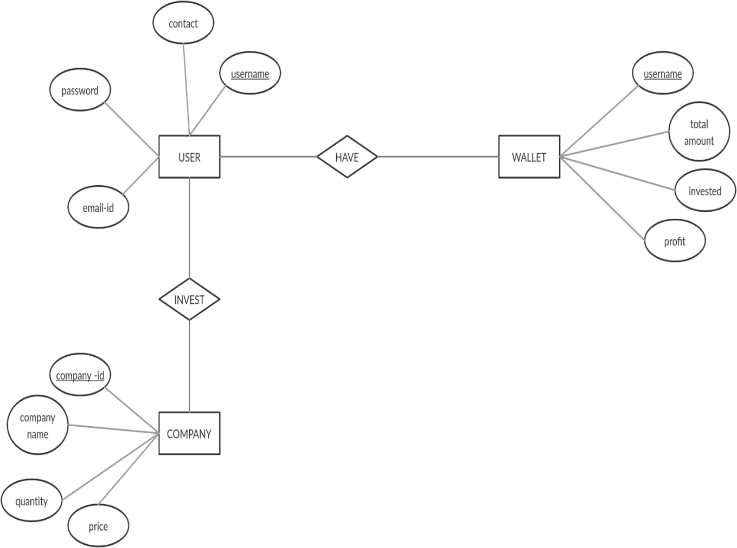

**3.2 UML Diagram**

**Sequence Diagram**

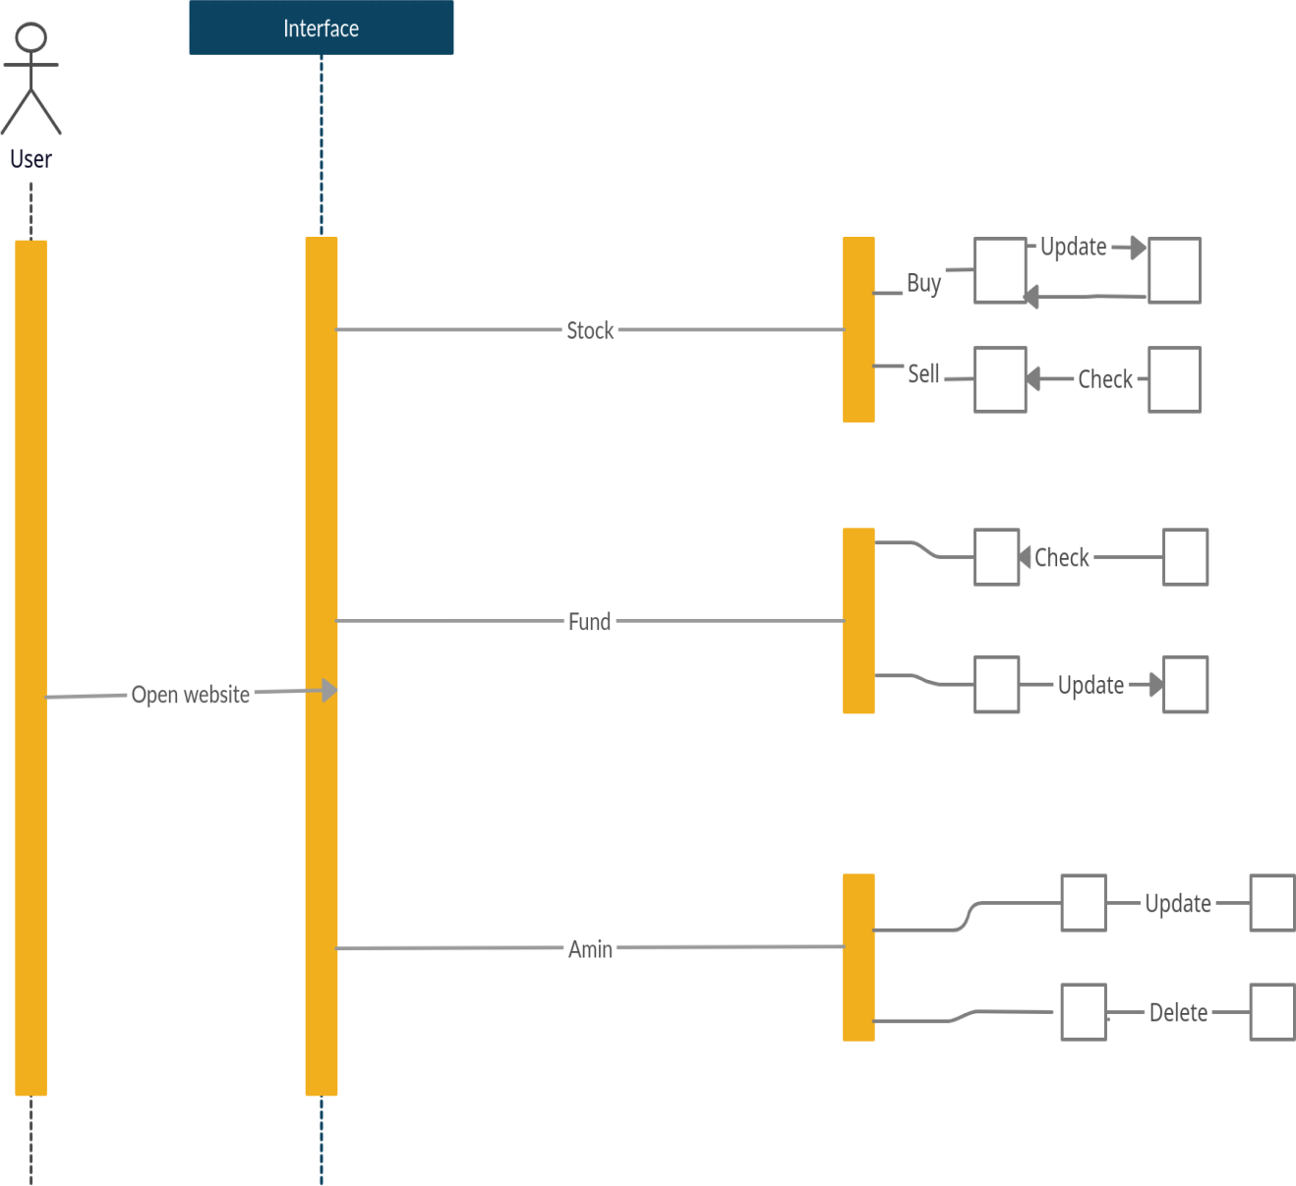

**Activity Diagram**

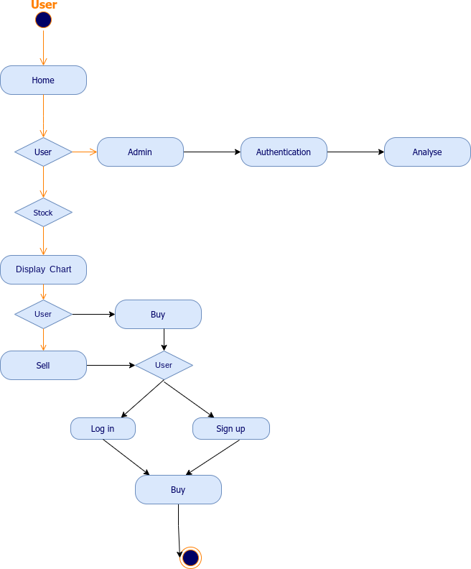

**Deployment Diagram**

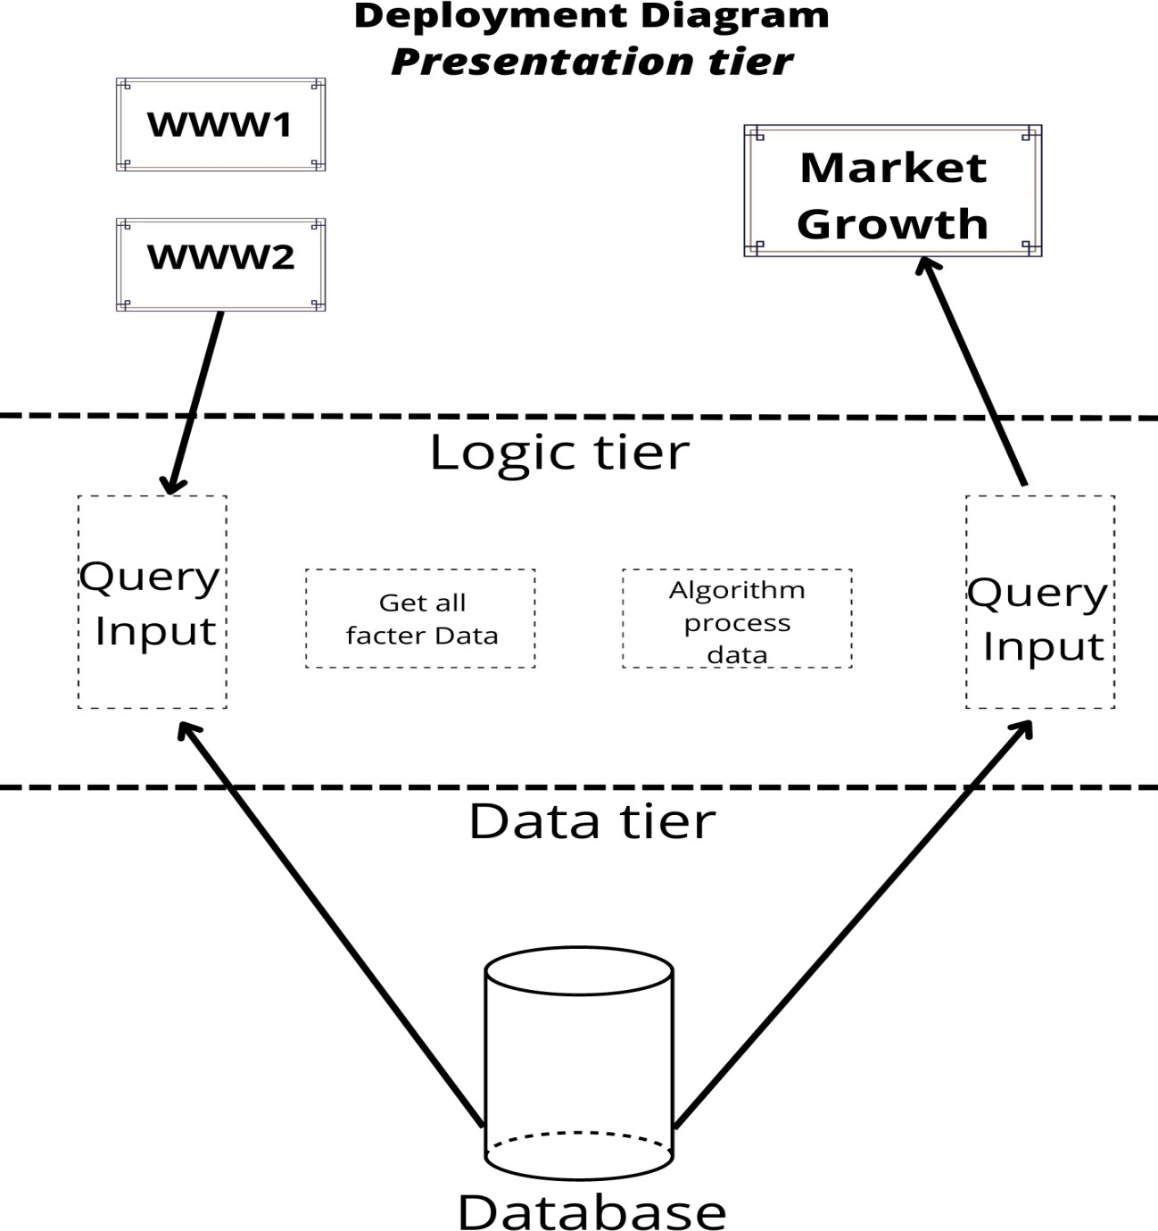

**3.3 Input and Output Screens**

**Homepage**

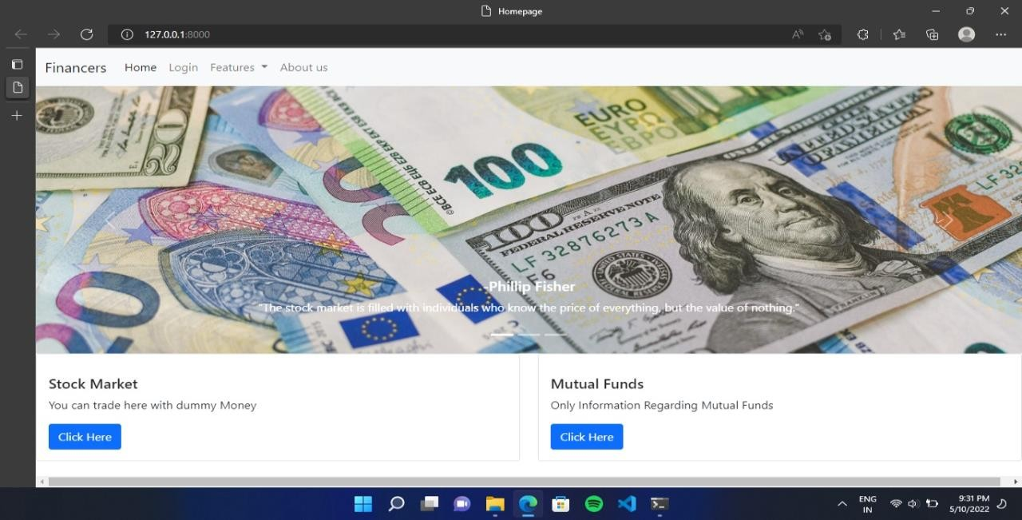

**Login Page**

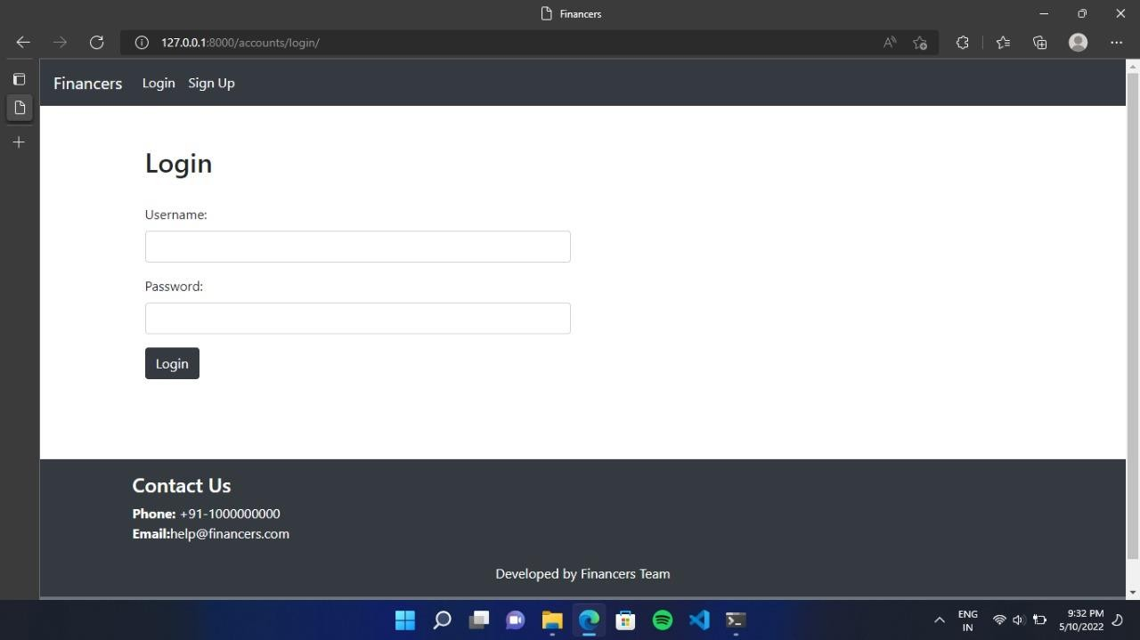

**Stock Page**

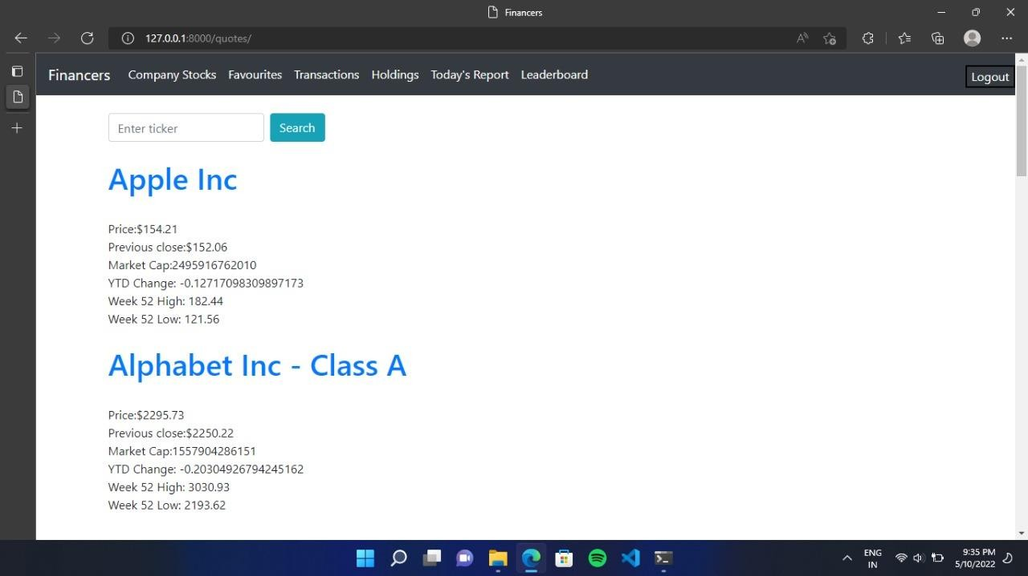

### Particular Stock

**Transaction**

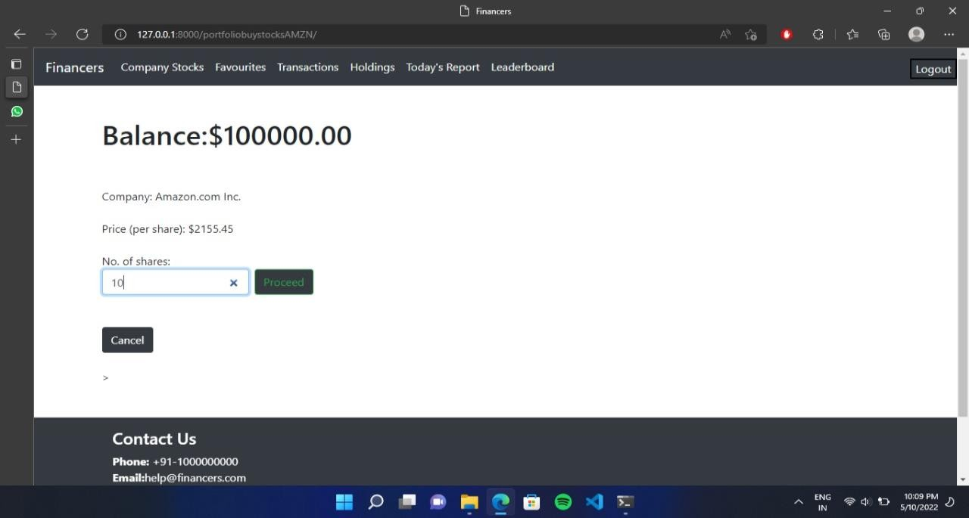

### Wallet

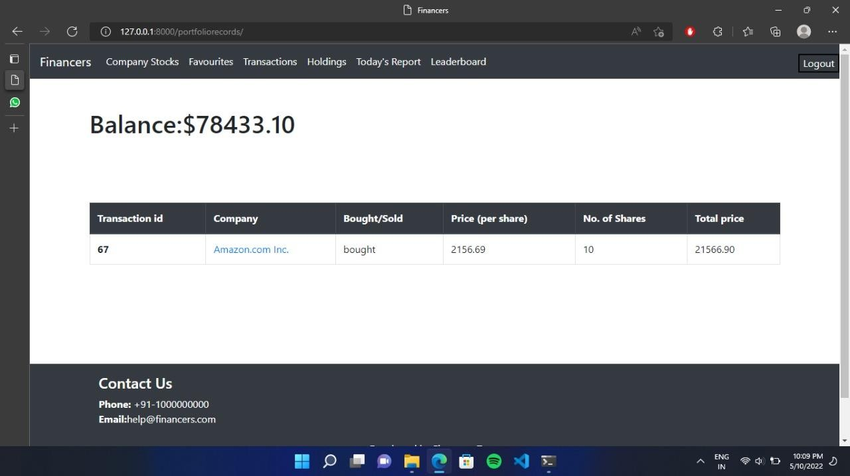

**Admin**

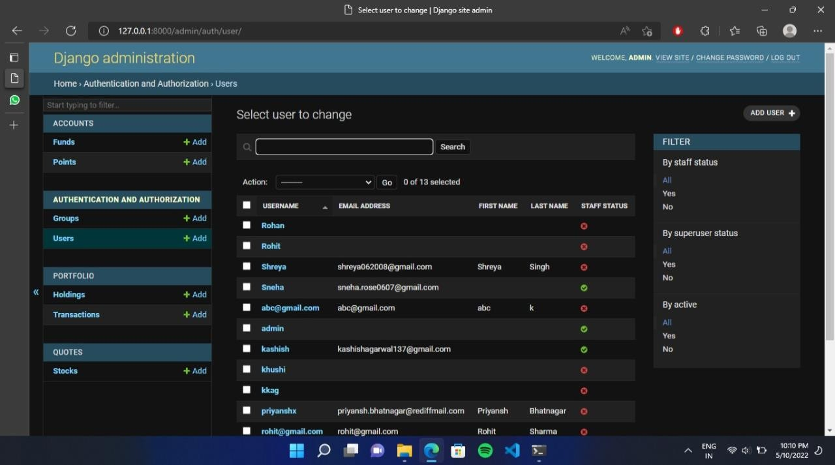

### Leaderboard

**Favorite Stock**

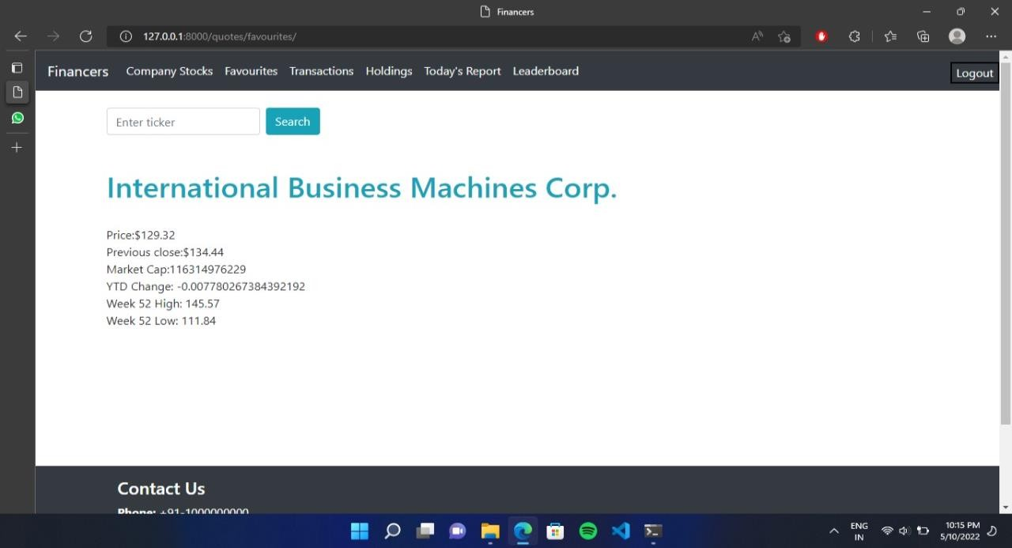

**Mutual Fund Blog**

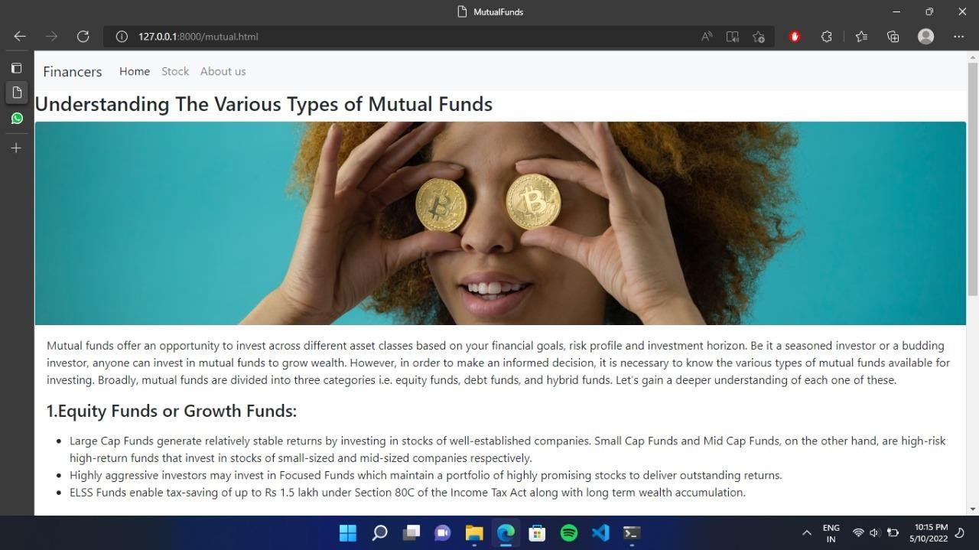

# 4. Testing

**4.1Test Case Design**

|  |  |  |  |  |  |
| --- | --- | --- | --- | --- | --- |
| Sr.no | Page | Input Case | Expected case | Actual Result | Pass/Fail |
| 1. | Sign up Page | 1. Empty Block of information 2. Wrong Email input 3. Mismatched Password | Requires all information Invalid Email  Authenticat ion Error | Requires all information  Invalid Email  Authenticati on Error | Pass  Pass  Pass |
| 2. | Login Page | 1. Empty data 2. Invalid Email 3]Invalid Email | All information required  Authenticat ion Error  Authenticat ion error | All information required  Authenticati on Error  Authenticati on Error | Pass  Pass Pass |
| 3. | Wallet | 1. Buy on empty wallet 2. Selling more   stocks than available | Insufficient Balance  Insufficient  Stocks Available | Insufficient balance  Insufficient  Stocks Available | Pass  Pass |
| 4. | Bypass login | Change in Pattern | Page not found | Page Not Found | Pass |
| 5. | Dos Attack | Dictionary of username  password | Block the attack | Blocked the attack | Pass |

# 5.Limitations and Future Enhancement

Financers does not contain the following features for now:

* + - News feed
    - Investment in Mutual funds
    - Online loan and EMI facility
    - SEO strategy
    - Campaign Landing page
    - Alert management
    - Custom Analytics Tracking

These features can be enhanced in future for better performance and engagement.

# 6.Conclusion

The project was successfully designed and is tested for accuracy and quality. In Financers, we have developed a secure, user-friendly Stock Trading System. This system is capable of taking care of each job that needs to be done in stock trading. The client can log in using a username and password. This means the unauthorized user cannot enter the system making it secure. Searching for perfect stock to buy can be easily done. Stock can be bought and sold at one click. This system would definitely reduce labor and make business more profitable and promising to clients.

# 7.References and Bibliography

#### [1] Lightweight Django by Elman and Mark Lavin

1. Django Unleashed by Andrew Pinkham

#### Test Driven Development with Django by Kevin Harvey

1. [WWW.W3SCHOOL.COM](http://WWW.W3SCHOOL.COM)

#### [WWW.GEEKSFORGEEKS.COM](http://WWW.GEEKSFORGEEKS.COM/)